Python File Handling & Automation
Task: File Handling, Automation Logic & Exception Handling in Python

1. Goal
This task demonstrates a solid, practical understanding of Python file handling, simple automation logic (rename / move / delete), and robust exception handling using try-except blocks.

2. Requirements Covered
- Read and write files (.txt and .csv)
- Automate file operations: rename, move, delete
- Use try-except for error handling on every file operation
- Explain code logic with clear inline comments

3. Approach
A single script, file_automation.py, simulates a small real-world automation pipeline: files 'arrive' in a workspace/incoming folder, get read and validated, renamed, and moved into workspace/archive, with every step logged to both the console and a timestamped automation_log.txt file. Two intentional failure cases (reading a file that no longer exists, and deleting a file that was never there) are included on purpose to prove the error handling works instead of crashing the program.

4. Full Python Script (file_automation.py)
"""
file_automation.py
-------------------
Goal: Understand Python file handling, automation logic, and exception handling.

This script demonstrates:
1. Reading and writing files (.txt and .csv)
2. Automating file operations (rename, move, delete)
3. Using try-except blocks for robust error handling
4. Clear comments explaining the logic at every step

Author: (your name)
"""

import os
import csv
import shutil
from datetime import datetime

# ----------------------------------------------------------------------
# SETUP: Define the folder structure we will work with.
# We create a "workspace" folder that contains an "incoming" folder
# (where new files "arrive") and an "archive" folder (where processed
# files get moved to). This mimics a real automation scenario, such as
# processing daily reports.
# ----------------------------------------------------------------------
BASE_DIR = os.path.join(os.getcwd(), "workspace")
INCOMING_DIR = os.path.join(BASE_DIR, "incoming")
ARCHIVE_DIR = os.path.join(BASE_DIR, "archive")
LOG_FILE = os.path.join(BASE_DIR, "automation_log.txt")

def setup_folders():
"""
Create the folder structure needed for the demo, if it doesn't
already exist. os.makedirs with exist_ok=True avoids raising an
error if the folder is already there.
"""
try:
os.makedirs(INCOMING_DIR, exist_ok=True)
os.makedirs(ARCHIVE_DIR, exist_ok=True)
log_action("Workspace folders verified/created successfully.")
except OSError as e:
# OSError covers permission issues, invalid paths, etc.
log_action(f"ERROR while creating folders: {e}")

def log_action(message):
"""
Simple logger: writes a timestamped message to both the console
and a log file. Using 'a' (append) mode so the log accumulates
across runs instead of being overwritten.
"""
timestamp = datetime.now().strftime("%Y-%m-%d %H:%M:%S")
entry = f"[{timestamp}] {message}"
print(entry)
try:
with open(LOG_FILE, "a", encoding="utf-8") as log:
log.write(entry + "\n")
except IOError as e:
# If we can't even write the log, just print a warning instead
# of crashing the whole automation.
print(f"[WARNING] Could not write to log file: {e}")

# ----------------------------------------------------------------------
# 1. TEXT FILE HANDLING
# ----------------------------------------------------------------------
def create_sample_txt(filename="notes.txt"):
"""
Writes a small sample .txt file into the 'incoming' folder.
Demonstrates basic file writing with the 'with' context manager,
which automatically closes the file even if an error occurs.
"""
path = os.path.join(INCOMING_DIR, filename)
try:
with open(path, "w", encoding="utf-8") as f:
f.write("Daily Automation Report\n")
f.write("========================\n")
f.write("Status: All systems operational.\n")
f.write("Files processed today: 3\n")
log_action(f"Created sample text file: {path}")
except IOError as e:
log_action(f"ERROR creating text file '{filename}': {e}")

def read_txt_file(filename="notes.txt"):
"""
Reads and prints the contents of a .txt file from the incoming
folder. Wrapped in try-except to gracefully handle a missing file
instead of letting the program crash.
"""
path = os.path.join(INCOMING_DIR, filename)
try:
with open(path, "r", encoding="utf-8") as f:
content = f.read()
log_action(f"Read text file '{filename}' successfully.")
print("----- FILE CONTENT START -----")
print(content)
print("----- FILE CONTENT END -------")
return content
except FileNotFoundError:
log_action(f"ERROR: '{filename}' not found in {INCOMING_DIR}.")
except IOError as e:
log_action(f"ERROR reading '{filename}': {e}")

# ----------------------------------------------------------------------
# 2. CSV FILE HANDLING
# ----------------------------------------------------------------------
def create_sample_csv(filename="employees.csv"):
"""
Writes a sample CSV file with a header row and a few data rows.
Uses the csv module's writer, which correctly handles commas,
quoting, and line endings for us.
"""
path = os.path.join(INCOMING_DIR, filename)
data = [
["ID", "Name", "Department", "Salary"],
[1, "Asha Rao", "Engineering", 75000],
[2, "Vikram Singh", "Marketing", 62000],
[3, "Priya Nair", "Finance", 68000],
]
try:
with open(path, "w", newline="", encoding="utf-8") as f:
writer = csv.writer(f)
writer.writerows(data)
log_action(f"Created sample CSV file: {path}")
except IOError as e:
log_action(f"ERROR creating CSV file '{filename}': {e}")

def read_csv_file(filename="employees.csv"):
"""
Reads a CSV file row by row using csv.reader and prints each row.
Demonstrates handling a missing file AND a malformed/empty file.
"""
path = os.path.join(INCOMING_DIR, filename)
try:
with open(path, "r", newline="", encoding="utf-8") as f:
reader = csv.reader(f)
rows = list(reader)
if not rows:
log_action(f"WARNING: '{filename}' is empty.")
return []
log_action(f"Read CSV file '{filename}' successfully ({len(rows)} rows).")
print("----- CSV CONTENT START -----")
for row in rows:
print(row)
print("----- CSV CONTENT END -------")
return rows
except FileNotFoundError:
log_action(f"ERROR: '{filename}' not found in {INCOMING_DIR}.")
except csv.Error as e:
log_action(f"ERROR parsing CSV '{filename}': {e}")
except IOError as e:
log_action(f"ERROR reading CSV '{filename}': {e}")

# ----------------------------------------------------------------------
# 3. AUTOMATION: RENAME, MOVE, DELETE
# ----------------------------------------------------------------------
def rename_file(old_name, new_name):
"""
Renames a file inside the incoming folder.
os.rename raises FileNotFoundError if the source doesn't exist,
and FileExistsError (on some platforms) if the target is invalid.
"""
old_path = os.path.join(INCOMING_DIR, old_name)
new_path = os.path.join(INCOMING_DIR, new_name)
try:
os.rename(old_path, new_path)
log_action(f"Renamed '{old_name}' -> '{new_name}'.")
except FileNotFoundError:
log_action(f"ERROR: Cannot rename. '{old_name}' does not exist.")
except FileExistsError:
log_action(f"ERROR: Cannot rename. '{new_name}' already exists.")
except OSError as e:
log_action(f"ERROR renaming '{old_name}': {e}")

def move_file(filename, destination_dir=ARCHIVE_DIR):
"""
Moves a processed file from 'incoming' to 'archive'.
shutil.move works even across different drives/partitions, unlike
os.rename in some cases, so it's the safer choice for 'move'.
"""
src = os.path.join(INCOMING_DIR, filename)
dst = os.path.join(destination_dir, filename)
try:
shutil.move(src, dst)
log_action(f"Moved '{filename}' to archive.")
except FileNotFoundError:
log_action(f"ERROR: Cannot move. '{filename}' does not exist.")
except shutil.Error as e:
log_action(f"ERROR moving '{filename}': {e}")
except OSError as e:
log_action(f"ERROR moving '{filename}': {e}")

def delete_file(filename, directory=ARCHIVE_DIR):
"""
Deletes a file (e.g., cleaning up old archives).
os.remove raises FileNotFoundError if the file is already gone,
and PermissionError if we don't have rights to delete it.
"""
path = os.path.join(directory, filename)
try:
os.remove(path)
log_action(f"Deleted '{filename}' from {directory}.")
except FileNotFoundError:
log_action(f"ERROR: Cannot delete. '{filename}' not found in {directory}.")
except PermissionError:
log_action(f"ERROR: Permission denied while deleting '{filename}'.")
except OSError as e:
log_action(f"ERROR deleting '{filename}': {e}")

# ----------------------------------------------------------------------
# 4. DEMO: RUN THE FULL WORKFLOW
# ----------------------------------------------------------------------
def run_demo():
"""
Ties everything together into one automation workflow:
1. Set up folders
2. Create sample .txt and .csv files
3. Read them back
4. Rename the .txt file
5. Move both files to the archive
6. Attempt an operation that will intentionally fail,
to prove the error handling works
7. Delete one archived file to demonstrate cleanup
"""
print("\n===== STARTING FILE AUTOMATION DEMO =====\n")

setup_folders()

# Step 1: Create sample files
create_sample_txt("notes.txt")
create_sample_csv("employees.csv")

# Step 2: Read them back to confirm contents
read_txt_file("notes.txt")
read_csv_file("employees.csv")

# Step 3: Rename the text file
rename_file("notes.txt", "daily_report.txt")

# Step 4: Move processed files into archive
move_file("daily_report.txt")
move_file("employees.csv")

# Step 5: Intentionally try to read a file that no longer exists
# in 'incoming' (it was moved) -- this proves our try-except
# catches the error instead of crashing the program.
print("\n--- Demonstrating error handling on a missing file ---")
read_txt_file("daily_report.txt") # no longer in incoming, will fail gracefully

# Step 6: Also demonstrate trying to delete a file that doesn't exist
print("\n--- Demonstrating error handling on a missing delete target ---")
delete_file("does_not_exist.txt")

# Step 7: Clean up - delete one archived file for real
print("\n--- Cleaning up: deleting archived CSV ---")
delete_file("employees.csv")

print("\n===== DEMO COMPLETE - check 'workspace/automation_log.txt' for the full log =====\n")

if __name__ == "__main__":
run_demo()

5. Sample Input
The script generates its own sample input files at runtime (no manual setup needed):
- notes.txt — a short status report (plain text)
- employees.csv — a 4-row employee table (ID, Name, Department, Salary)

6. Sample Output / Screenshots
Step 1 — Creating the sample .txt/.csv files and reading their contents back:
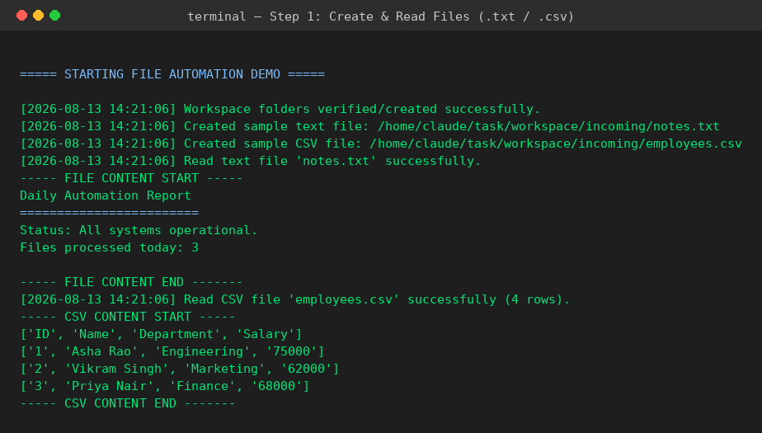
Figure 1: Console output — file creation & reading
Step 2 — Renaming, moving, deleting files, and the two intentional error cases handled gracefully by try-except:
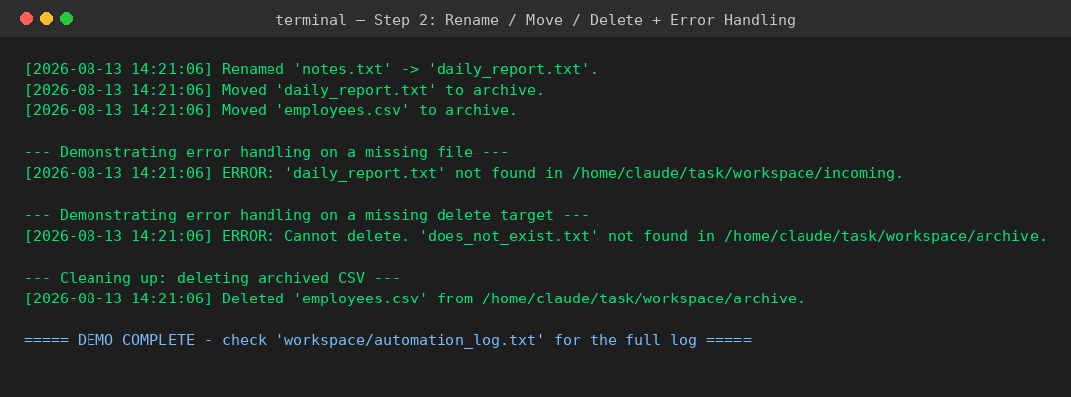
Figure 2: Console output — automation (rename/move/delete) & error handling

7. Key Exception Handling Logic
Every file operation is wrapped in a try-except block that catches specific, expected exceptions before falling back to a general one, so the program always logs a useful message instead of crashing:
- FileNotFoundError — reading/renaming/deleting a file that doesn't exist
- PermissionError — deleting a file without the right permissions
- FileExistsError — renaming to a name that's already taken
- csv.Error — malformed CSV content
- IOError / OSError — general fallback for filesystem issues

8. How to Run
python3 file_automation.py
This creates a workspace/ folder next to the script, runs the full demo end-to-end, and writes a persistent log to workspace/automation_log.txt.

